**Coursework 2 Assessment- SET08119**

What advantages are of the 3-layered approach to building applications?

The architecture of 3 layer give us the ability to update the technology stack of one tier without impacting others areas of the application.

In fact we are able to scale the application up and out. For example in our coursework in the presentation layer we have a GUI, which contains all things that are visible (trains and booking) to the user such as screen layout. The business layer is the core of the system this is the link between other layers and contains runtime values like train ID in our example. And finally we have the data layer, which takes care of persistency, indeed in our coursework I implemented a binary formatter and serialized my classes in order to save every train in a bin file and load it when the project is started.

To conclude the 3 layered approach saves development manpower. It provides scalability, performance and availability.

With an example, explain why using design patterns can make the design of an OO system easier to understand.

A design pattern provides a general reusable solution to a common design problem. Design patterns are very useful as they solve recurring problems and in general simplify code. For example a Facade pattern allow us to simplify how to use an existing system. This design patterns make the design of an OO system easier. First of all, it enables us to use a complex system more easily, indeed we have a complicated system of which we need to use only a part so we use that design and we end up with a simpler, easier-to-use system. Secondly, it is easy to implement (eg. Define a new class that has the required interface). Finally, even though the facade simplifies the use of the required sub-system, the facade is not complete; certain functionality may be unavailable to the client.

**Architecture**

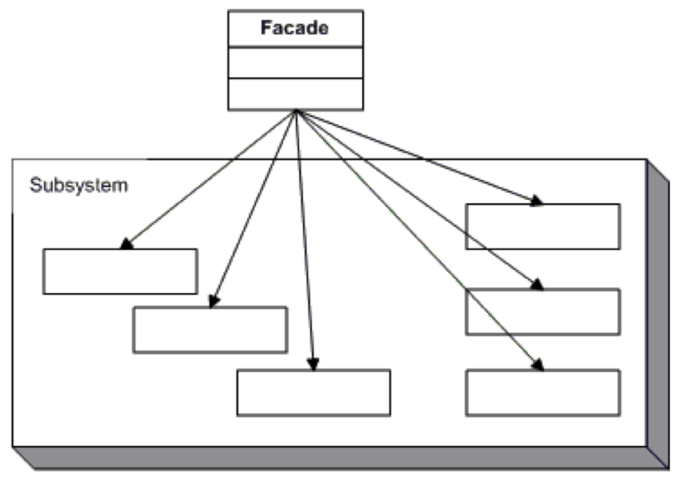

http://www.dofactory.com/net/facade-design-pattern